**WEEK 5-MANDATORY HANDS ON EXERCISES**

**Module 8 - Microservices with Spring Boot 3 and Spring Cloud**

**Creating Microservices for Account and Loan — My Hands-on Journey**

In this practical session, I created **two independent Spring Boot microservices** for a bank — one to handle **Accounts**, and the other for **Loans**. Each service is a separate Maven-based Spring RESTful web application with its own pom.xml. Instead of combining everything into one monolith (old-school style), the system is split into two clean, focused services.

Both services are basic — no backend/database connectivity, just dummy data for now. Think of it as the skeleton before we flesh it out.

**🧾 Account Microservice**

**Setup:**

1. Created a folder with my **employee ID** on the D: drive.
2. Inside it, created a **microservices** folder to store all future sample microservices.
3. Jumped over to <https://start.spring.io>:
   * **Group:** com.cognizant
   * **Artifact:** account
   * Selected:
     + **Spring Boot DevTools**
     + **Spring Web**
4. Generated and downloaded the zip, then extracted it to the microservices folder.

**Development:**

1. Navigated into the account folder via command prompt and ran:

go

mvn clean package

1. Imported the project into **Eclipse**.
2. Created a controller with a **GET** endpoint:

/accounts/{number}

1. Returned dummy data (no DB):
2. Ran the application and tested the service via browser/Postman — ✅ works like a charm on port **8080**.

**Loan Microservice**

**Setup:**

1. Repeated the same steps from the Account service.
2. This time, the **Artifact** was loan.

**Development:**

1. Implemented a controller with this **GET** endpoint:

/loans/{number}

1. Returned dummy loan details
2. Tried to launch it while Account service was still running and... **Port conflict**! Classic.

**Fix:**

1. Modified application.properties of the Loan microservice:

ini

server.port=8081

1. Relaunched — now running smoothly on **port 8081**.

**✅ Final Outcome**

Both microservices are now:

* Independently runnable
* Exposing simple REST endpoints
* Running on separate ports (8080 for Account, 8081 for Loan)

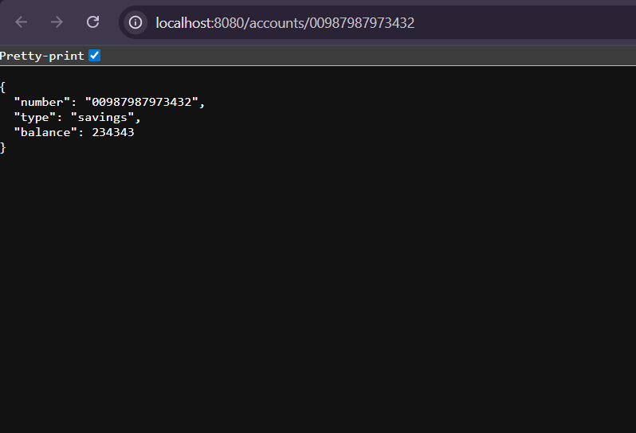Output:

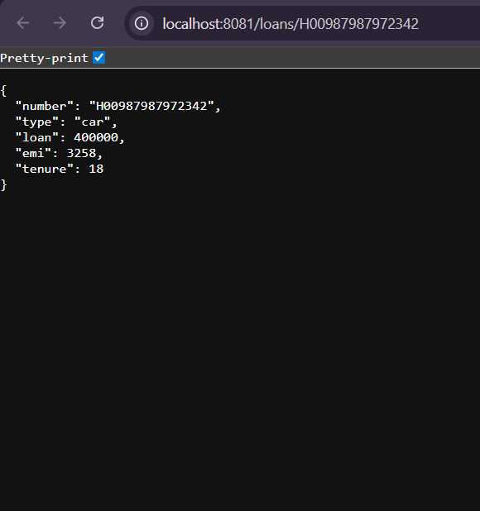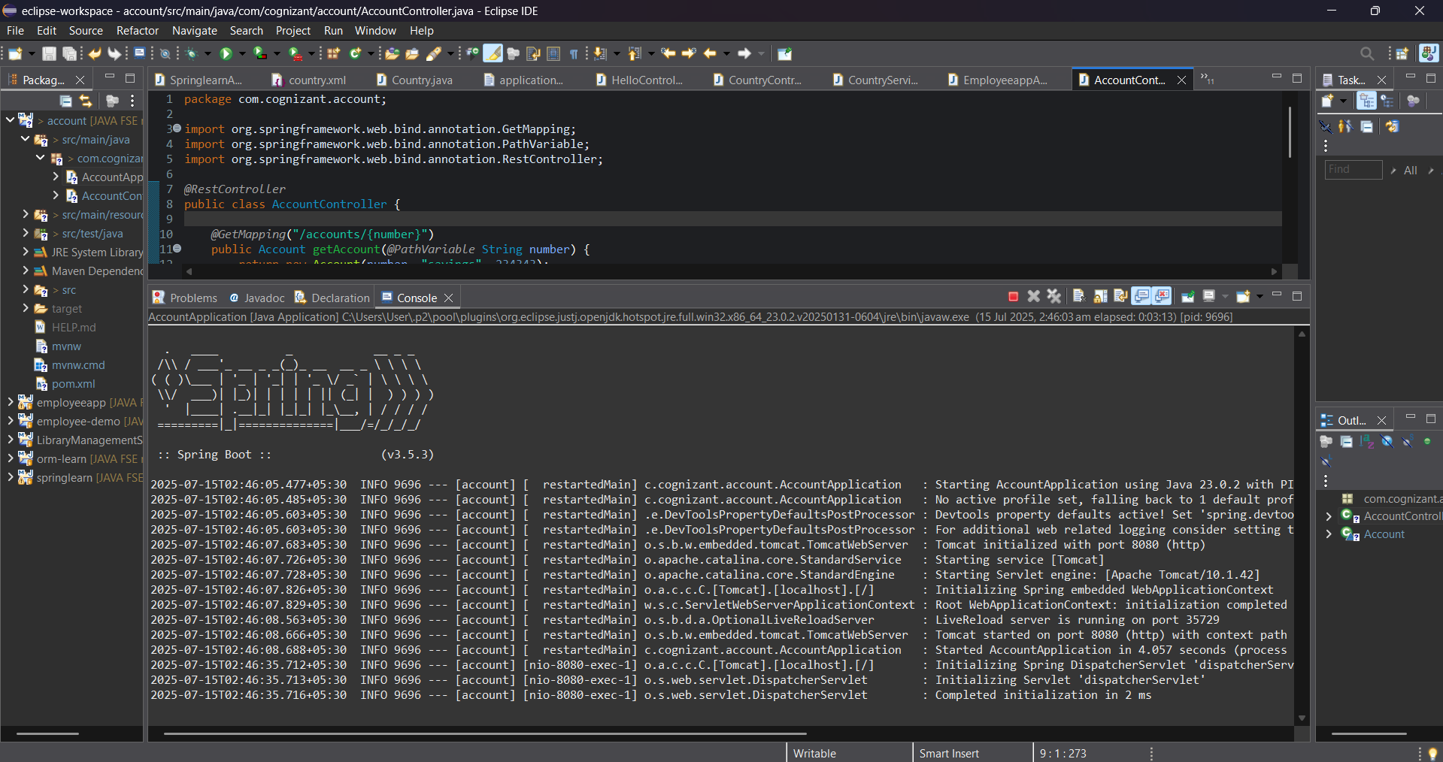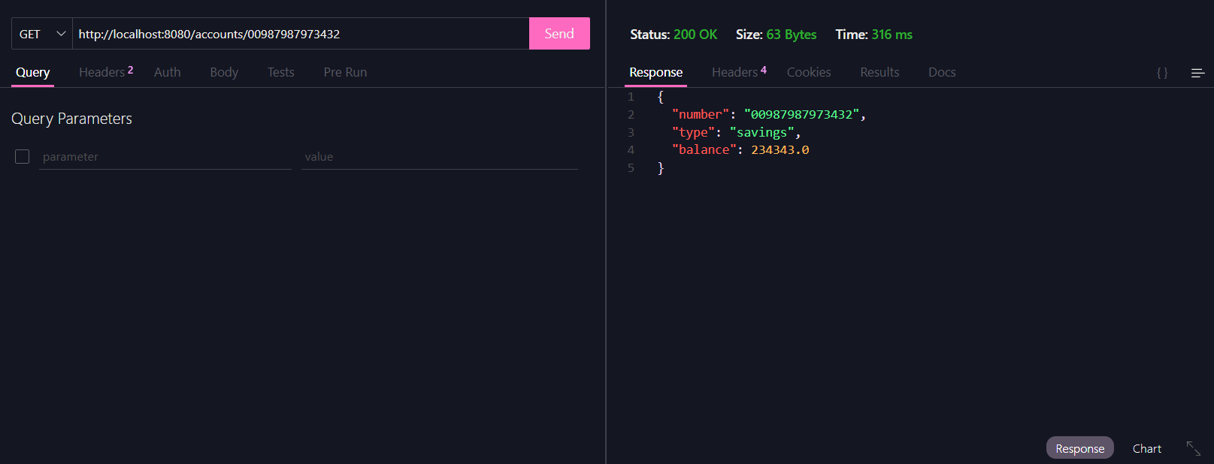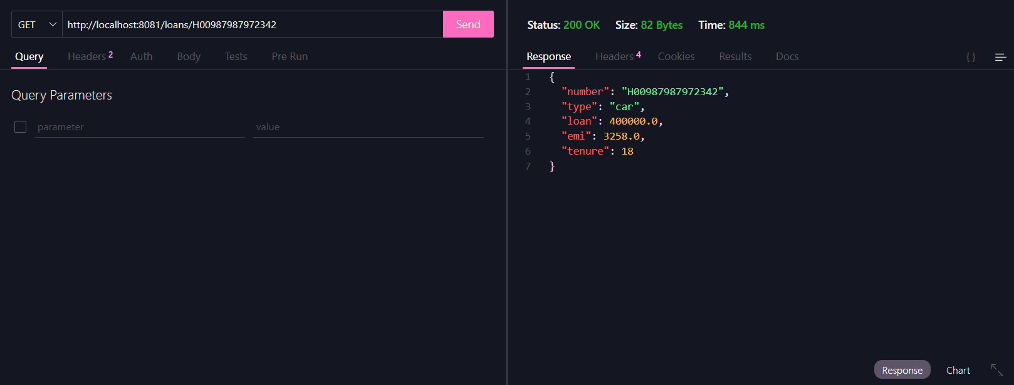

**WEEK 5-ADDITIONAL HANDS ON EXERCISES**

**Create Eureka Discovery Server and register microservices**

**Setting up Eureka Discovery, Registering Microservices, and Routing via Spring Cloud API Gateway (From My POV)**

Microservices are like that group project where each member *finally* does their part independently — and Eureka is the chill friend keeping track of who's present. Here's how I went from zero to a functional discovery ecosystem with API routing and request logging. Let’s go 🚀

**Step 1: Creating Eureka Discovery Server**

Eureka Discovery Server is where all our microservices announce, “Hey, I’m online!” Consumers can then discover and call these services without hardcoding URLs.

**🔨 Setup:**

1. Went to [start.spring.io](https://start.spring.io) and configured:
   * **Group:** com.cognizant
   * **Artifact:** eureka-discovery-server
   * **Dependencies:** ✅ Spring Cloud Discovery > Eureka Server
2. Downloaded the zip, extracted, and built it:

mvn clean package

1. Imported into **Eclipse**, and in the main class, added:

@EnableEurekaServer

1. Then I opened application.properties and dropped in:

server.port=8761

eureka.client.register-with-eureka=false

eureka.client.fetch-registry=false

logging.level.com.netflix.eureka=OFF

logging.level.com.netflix.discovery=OFF

1. Ran the app and visited <http://localhost:8761> — Eureka dashboard showed up! (Empty for now, but not for long.)

**🧾 Step 2: Registering Microservices (Account & Loan)**

Next up: get the **Account** and **Loan** microservices to introduce themselves to Eureka.

**For Each Microservice:**

1. Headed to [start.spring.io](https://start.spring.io) and reconfigured:
   * **Group:** com.cognizant
   * **Artifact:** account or loan
   * **Dependencies:**
     + Spring Web
     + Spring Boot DevTools
     + Eureka Discovery Client
2. Used the “Explore” button to grab the generated pom.xml and pasted it into the existing account/loan project to update dependencies.
3. Rebuilt with:

mvn clean install

1. In AccountApplication.java / LoanApplication.java, added:

@EnableDiscoveryClient

1. Updated application.properties:

spring.application.name=account-service # or loan-service

eureka.client.serviceUrl.defaultZone=http://localhost:8761/eureka

1. Killed all running services in Eclipse (Eureka, Account, Loan) — used the Console View > Monitor icon > Terminate.
2. Restarted in this order:
   * Eureka Server (localhost:8761)
   * Account Service
   * Loan Service
3. Boom — both services appeared in the Eureka dashboard under **"Instances currently registered with Eureka"** ✅

**Step 3: Creating an API Gateway & Logging Requests**

Now to make things fancy — a gateway to route all requests + log them globally.

**🔁 Greet Service (Microservice #3)**

1. Created a new microservice greet-service via Spring Initializer:
   * **Dependencies:**
     + Spring Web
     + Eureka Discovery Client
2. Configured application.properties:

spring.application.name=greet-service

server.port=8082

eureka.client.serviceUrl.defaultZone=http://localhost:8761/eureka

1. Made a simple controller:

@RestController

public class GreetController {

@GetMapping("/greet")

public String greet() {

return "Hello World";

}

}

1. Ran it, confirmed it registered with Eureka, and /greet worked on port 8082.

**API Gateway**

1. Created another service: api-gateway with:
   * Spring Cloud Gateway
   * Eureka Discovery Client
2. Configured application.properties:

spring.application.name=api-gateway

server.port=9090

eureka.client.serviceUrl.defaultZone=http://localhost:8761/eureka

spring.cloud.gateway.discovery.locator.enabled=true

spring.cloud.gateway.discovery.locator.lower-case-service-id=true

1. Confirmed api-gateway showed up in Eureka.
2. Accessed the greet service via:

http://localhost:9090/greet-service/greet

It routed correctly

**Logging All Incoming Requests — Global Filter**

To track every hit to the API Gateway (because devs *love* logs):

1. Created LogFilter.java in api-gateway:

@Component

public class LogFilter implements GlobalFilter, Ordered {

@Override

public Mono<Void> filter(ServerWebExchange exchange, GatewayFilterChain chain) {

System.out.println("Incoming Request: " + exchange.getRequest().getURI());

return chain.filter(exchange);

}

@Override

public int getOrder() {

return -1;

}

}

1. Accessed:

http://localhost:9090/greet-service/greet

1. Checked the Gateway console — got:

Incoming Request: /greet-service/greet

And that’s how I made my gateway paranoid enough to log every incoming guest

**Final Result**

|  |  |  |  |
| --- | --- | --- | --- |
| **Component** | **Port** | **Registered with Eureka?** | **Role** |
| Eureka Server | 8761 | No | Service registry |
| Account Microservice | 8080 | Yes | Provides account info |
| Loan Microservice | 8081 | Yes | Provides loan info |
| Greet Microservice | 8082 | Yes | Returns "Hello World" |
| API Gateway | 9090 | Yes | Routes & logs requests |

